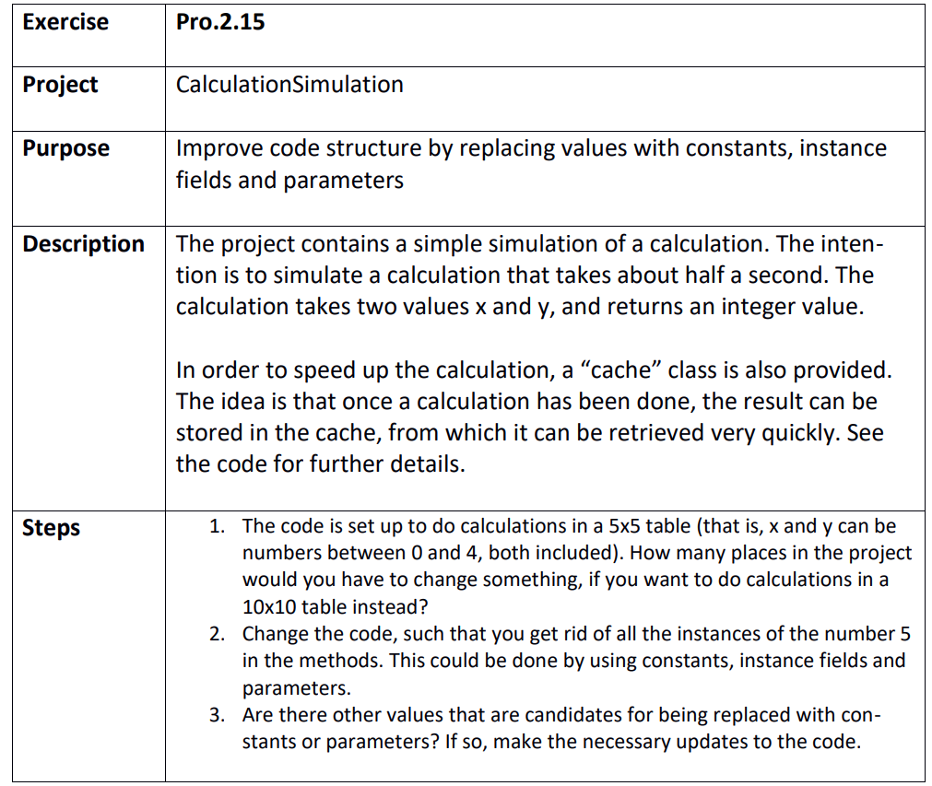

Step 1
CalculationSimulation.sln
8 places across 3 classes

Step 2
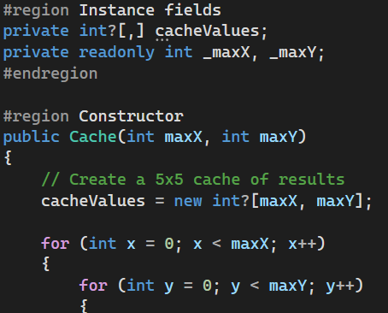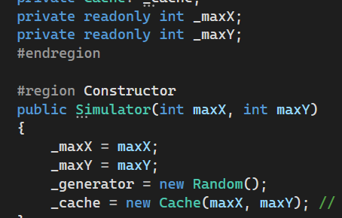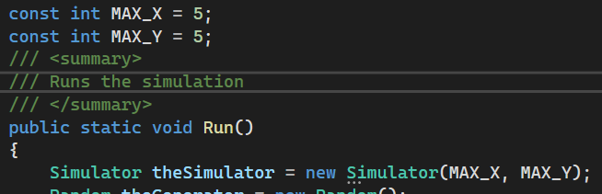

Step 3
The amount of iterations 1000 could be a const or variable.
The minX and minY could be
The three numbers in the do calculations could

